**Strengthening Productive Capacity and Resilience of Smallholder Sweet potato Producer Organizations in Uganda**

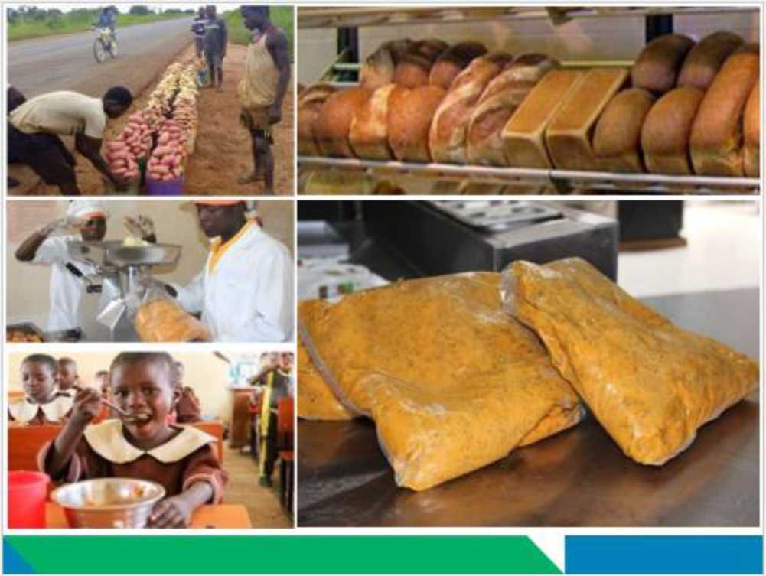

**TECHNICAL PROPOSAL**

September 2021

Section 1: Basic Data

|  |  |  |
| --- | --- | --- |
| a. Project Name | Strengthening productive capacity and resilience of smallholder sweet potato producer organizations in Uganda | |
| b. Country and Region | Uganda - Eastern | |
| c. Producer  Organization (PO) | Soroti Sweet potato Producers and Processors Association (SOSPPA) | |
| Address**:** P**.**O. OMORRIO, Kyere Town Council, Serere District, Uganda | |
| Registration  SN/205/2019 | Yes  First registration: July 17, 2006 (Under Soroti district).  Renewed: August 9, 2019 (Under Serere district Local Government). |
| PO website or link to annual report |  |
| Primary Activities of PO | * Seed production and multiplication * Primary processing and value addition of   cassava and sweet potato into baked products   * Training of farmers, farmer groups, and other   institutions   * Dissemination of technologies (sweet potato,   cassava, sorghum, groundnuts, green gram, and cowpea), knowledge and skills   * Collaborate with research organizations -   NaSaRRI in Serere - through on farm trials   * Support saving and credit schemes * Provide linkage to markets and engage in   group marketing |
| Type of target farmers | Smallholder farmers, 50% women in rural and urban zones |
| d. PO Mission Statement | To promote a community-oriented civil society association in Teso Region promoting sustainable livelihood enterprises | |
| e. PO Focal Person (for this project) | Name: Okalebo Joseph  Title: Coordinator  Email: [joscphamikirot@gmaiLcom](mailto:josephamikirot@gmail.com) or [sosppa2012@gmail.com](mailto:sosppa2012@gmail.com) | |
| f. SE Focal Person | 1. Franklin Mutahakana (Senior Operations Officer; [fmutahakana@worldbank.org)](mailto:fmutahakana@worldbank.org) 2. Joseph Oryokot (Senior Agriculture Specialist; [joryokot@worldbank.org)](mailto:joryokot@worldbank.org) | |

|  |  |
| --- | --- |
| g. Total GAFSP Grant Funding Requested *(refer to Annex 1 - Project Budget Table)* | Amount Requested: US$ 2,500,000.00 |

1. Estimated project start and end date: January 2022 - December 2025
2. Preferred Supervising Entity (Select only one)

* African Development Bank (AfDB)
* Asian Development Bank (ADB)
* International Fund for Agricultural

Development (IFAD)

* Inter-American Development Bank (IDB)
* Food and Agriculture

Organization (FAO)

IXI World Bank (WB)

* World Food Programme (WFP)

1. Has the PO previously received a GAFSP Missing Middle Initiative grant? □Yes, please complete *Annex 4*

/□No

**Section 2. Project Description (weighting 35%) (suggested 6-8 pages)**

* 1. **Project Development Objective** (max. 2 sentences)

The Project Development Objective is **to increase production and consumption of sweet potato and build the resilience of the smallholder producers and processors for economic value addition in project areas.**

The proposed project will respond to the threat of COVID-19 to food, nutrition, and income security by supporting the Soroti Sweet potato Producers and Processors Association (SOSPPA) to increase its investment in production, processing, and value addition of biofortified orange-fleshed sweet potato (OFSP) products. This project will strengthen the organizational capacity and professional performance of the SOSPPA to support their member farmers through technical, business, and financial services to increase farm productivity and economic value of harvested crops and thereby build the resilience of the rural economy and livelihoods in the Teso sub-region of Eastern Uganda to shocks including COVID-19.

* 1. **. Description of the proposed project**

COVID-19 has created unprecedented challenges to smallholder farm households and communities across the rural and urban food systems in Uganda. The inter- and intra-community movement restrictions through lockdowns and curfews imposed by governments have caused significant disruptions to the economic connectedness that drive and sustain local, regional, and national supply and demand in output and input markets. Access to inputs (foundation/certified seed, credit, crop insurance) have been affected by transport restrictions and market closures. Immediate and midterm negative effects on commodity prices earned by farmers, household income, food security, and diet quality have been observed. These outcomes further compound pre-COVID challenges for smallholder-based agricultural value chains in Uganda stemming from high input and transaction costs and very limited investments in infrastructure and services. There is, therefore, urgent need to target technical and business development support to strengthening the capacity of key stakeholders for pursuing new and promising market opportunities in these value chains.

In this regard, producer organizations (POs) play a pivotal role. POs provide farmers with reliable input and output markets and mitigate market failures which constrain their associated ability to do business. They can use collective bargaining to get discounted input prices and higher output prices for members. They can also facilitate farmers’ access to distant markets through joint marketing. POs therefore play a critical role in building the resilience of rural communities in the presence of systemic shocks such as pandemics and droughts. However, in countries like Uganda, weak technical competence and management capacity and poor governance often severely limit the performance of POs and prevent them from harnessing collective action amongst their members to thrive and grow. These limitations must and can be overcome through targeted capacity strengthening of POs such as SOSPPA. In this case, there are strong market opportunities for expanding and diversifying production and value addition of sweet potato and other crops grown by its members. In particular for sweet potato, SOSPPA can utilize technologies and management practices developed by its partners, including the International Potato Center (CIP), to accelerate product development and marketing on the basis of a solid understanding of market demand.

Sweet potato is a versatile and resilient crop with proven performance in diverse agro-ecologies including in low-input smallholder production systems and in rebuilding livelihoods of farm households and communities after droughts, floods, or displacement. It is climate-smart, matures in just three months, and has long underground storability of up to 6 months. The crop provides reliable yields of at least 8 t/ha under varying climatic and soil conditions, making it one of the fastest expanding food crops in Africa over the past 20 years. Biofortified orange-fleshed sweet potato (OFSP) varieties, rich in beta-carotene, are highly effective in combating vitamin A deficiency among children under 5 years of age and pregnant and lactating women. OFSP has been adopted by more than 6.5 million farmers in Africa and South Asia since 2010, including more than 300,000 farmers in Uganda.

Increasingly, OFSP is also used as an ingredient in the local food processing sector in Uganda, though volume and scope are still limited as compared to other OFSP producing countries like Kenya, Malawi or South Africa. SOSPPA and its partners, specifically CIP, have been piloting a range of OFSP processing options including flour, buns, confectionaries, juices and the manufacturing of animal feed (silage) from by-products. While all of these options are technically feasible, the comparative advantage of OFSP as an ingredient lies in its novelty, low cost, and nutritional value which can fetch a premium in some market segments. In this regard, the production of fresh OFSP puree provides a high-value and versatile intermediary product that can be further processed (and combined with other local ingredients) into a range of foods from bakery items to porridges, juices and spaghetti/pasta. Unlike flour, puree retains almost all of the nutritional value of OFSP throughout the processing cycle and these products are therefore also suitable for institutional markets that prioritize healthy diets, such as schools and hospitals. This project will identify the most promising market segments for specific OFSP based products, and on this basis update and expand SOSPPA’s current investments in processing and value addition.

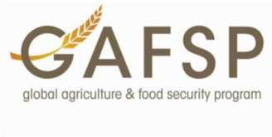

The Uganda Multi-sectoral Food Security and Nutrition Project (UMFSNP) and International Potato Center (CIP), together with the World Food Programme (WFP) under the Development and Delivery of Biofortified Crops at Scale (DDBIO) project, are promoting OFSP production and consumption in Eastern and Northern Uganda to strengthen the resilience of livelihoods and nutritious food supply chains affected by COVID-19.

The overarching goal of this project is to build the capacity and resilience of SOSPPA in Uganda to respond to the COVID-19 pandemic and other shocks by improving food, nutrition, and income security of its members. This will be achieved through processing and value addition and the promotion of profitable and sustainable sweet potato based innovations and linkage to markets, financing, and weather insurance in Katakwi, Serere, Soroti, Bukedea, Ngora, and Amuria districts. The project will harness the experiences of UMFSNP and CIP/WFP’s DDBIO projects, and build on the ongoing Agriculture Cluster Development Project’s (ACDP) value chain development initiative, in pursuing the specific objectives of the proposed project including: (a) Improve market access and farm incomes for SOSPPA farmers through OFSP marketing, processing, and value addition supported by effectively managed facilities and trainings; (b) Increase productivity and production of sweet potato roots and vines, and other nutritious crops, amongst SOSPPA farmers with yield-enhancing inputs improved, and climate smart agricultural practices; (c) Promote diversified utilization and consumption of OFSP products amongst SOSPPA members and in current and new markets; and (d) Strengthen SOSPPA’s governance and management capacities to deliver services to its members.

**Project Components:**

*Component 1*: Improve market access and farm incomes for SOSPPA farmers through OFSP marketing, processing, and value addition supported by effectively managed facilities and trainings.

*Component 2*: Increase productivity and production of sweet potato roots and vines, and other nutritious crops, amongst SOSPPA farmers with yield-enhancing inputs, improved and climate smart agricultural practices.

*Component 3*: Promote diversified utilization and consumption of OFSP products amongst SOSPPA members and in current and new markets.

*Component 4*: Strengthen SOSPPA’s governance and management capacities to deliver services to its members.

**Project Activities:**

Over a four-year period, the project will implement a specific set of activities under each project component as described below.

**Activities under Component 1: Improve market access and farm incomes for SOSPPA farmers through OFSP marketing, processing, and value addition supported by effectively managed facilities and trainings**

Teso sub-region is the leading producer of sweet potato. Farmers normally harvest their crop at the same time (June-August and November-January). During these peak harvest seasons, high supply, and other endemic market failures, result in very low prices for fresh roots. Storing sweet potato roots underground for long is limited by weevil infestation that makes roots lose market and consumption value. Farmers therefore typically resort to preserving their surplus roots as *amukeke* (the chipped and dried roots). However, *amukeke* has little market beyond the region. It is also easily attached and destroyed by weevil in the store turning it into flour and further reducing its value. SOSPPA was established in 2004 to help its members overcome such constraints,

and increase their farm incomes, by developing commercial value chains for sweet potato (especially OFSP) and cassava.

Building on past experience and the on-going ADCP/MAAIF cassava value chain development, SOSPPA has pursued a three-pronged approach to OFSP value chain development namely, the production and sale of quality vines, production and sale of fresh roots, and cottage-based processing of fresh roots into dry chips and assortment of fried products. Vines and fresh roots are sold to institutional markets (schools, colleges, and NGOs), dry chips to private flour processors while fried OFSP products (including mandazi, donuts, and small shortcakes (Figure 1, in Annex 6) are sold mainly locally to community members due to lack of Uganda National Bureau of Standards (UNBS) certification. Under this Component, the project will implement three broad sets of activities: i) upgrading OFSP value addition and processing into nutritious products for low, middle, and high-end markets; ii) expanding the market for fresh roots and quality vines; and iii) converting by-products of OFSP processing to nutrition animal feed (namely, silage).

*Upgrading OFSP value addition and processing into nutritious products for low, middle, and high-end markets:* To upgrade SOSPPA’s current processing activities into profitable commercial businesses, this project will: i) Market assessment to identify most promising and profitable market segments for specific OFSP products. ii) Develop and test commercial value added OFSP products, including laboratory analysis to assess the nutritional composition of processed products.

1. Construct a processing facility focused on OFSP-based commercial consumer products and managed by SOSPPA. That is, procure, install, and test equipment for production.

SOSPPA has been unable to reach local, middle, and high-end formal markets/retails stores (*duukas* and supermarkets) with its products mainly due to lack of certification by the Uganda National Bureau of Standards (UNBS). Past attempts failed because of detection of higher bacterial load in the processed products than the recommended threshold. The project will therefore:

1. Train SOSPPA on equipment use and good food manufacturing practices, including hazard analysis and critical control points (HACCP).
2. Support SOSPPA to obtain UNBS certification implementing and complying with the requisite food industry standards including HACCP and UNBS.

*Expanding market for fresh roots and quality vines*: To deepen markets access, SOSPPA will continue strengthening institutional markets (currently only focusing on primary schools and colleges in Serere district) while exploring new market opportunities by: i) expanding to other districts (Katakwi, Ngora, Soroti, Amuria, and Bukedea); ii) extending the list of institutional markets to include secondary and high schools, prisons, and hospitals; iii) targeting the expanded institutional markets with a wider portfolio of OFSP products; and iv) promoting the use of nutritious OFSP puree in the low-end informal markets, especially the *rolex* street vendors.

*Converting by-products of sweet potato processing into animal feed*: OFSP production and processing can generate large amounts of by-products, namely vines and non-marketable roots. At the farm, sweet potato vines and damaged, small-size, weevil-infected or other non-marketable roots are left behind during harvesting. Processing sweet potato by-products into silage is a win-win investment that produces nutritious low-cost animal feed and reduces the environmental footprint of sweet potato. Sweet potato vines contain 19-22% crude protein making it a high-quality animal feed. This project will process these by-products into nutritious animal

**^AFSP**

global agriculture & food security program

feed through silage processing thus creating a market for the wastes, and income for farmers. Specifically, the project will:

1. Establish sweet potato “silage hubs” based on the model developed by CIP, and currently in successful use in central and eastern Uganda by a youth group (the Bavubuka Twekembe Youth Group) providing employment and income to the youth. One silage processing hub will be set up in each of the six project districts to provide market for vines and waste roots generated by SOSPPA groups in the district.
2. Train farmers on recommended animal feeding, how to diversify animal feeding, mixing sweet potato silage with grass to reduce cost, animal feeding supplementation regimens for improved livestock productivity, and silage marketing.
3. Provide training to the hubs on business plan development to make them sustainable businesses.
4. Train farmers on advocacy to empower them to lobby for a better business environment.

**Activities under Component 2: Increase productivity and production of sweet potato roots and vines, and other nutritious crops, amongst SOSPPA farmers with yield-enhancing inputs, improved and climate smart agricultural practices.**

Year-round supply of fresh roots and vines will be critical to ensure that the processing facility can receive a steady supply of roots and operate at full capacity. SOSPPA currently has 1,200 members organized in groups of 25-30 members that produce sweet potato roots and planting material. To integrate the root production activities with the processing and value addition initiatives, manage weather risks and encourage investment, the project will implement the following activities:

*Strengthen the capacity of vine multipliers to provide quality seeds/vines to farmers*: The project will increase farmers’ access to quality seed by strengthening the existing 10 vine multipliers in Serere district, and recruiting and training two multipliers (1 male, 1 female) in each of the 5 new districts (i.e., Katakwi, Soroti, Amuria, Ngora and Bukedea). The project will link the vine multipliers to: i) source of foundation seed; and ii) certification services. These will be provided as a loan and deducted from vine sales (i.e., an interlinked credit scheme). To reduce certification costs, the project will seek certification of all SOSPPA-affiliated vine multipliers collectively under SOSPPA (not as separate entities) thus reducing per multiplier/unit costs. Vine multipliers will also have access to a credit line and weather insurance scheme also paid through vine sales. The former will encourage investment in foundation seed, irrigation, and other complementary inputs (fertilizer and pesticides), increased yields and thus ensure year-round supply of vines and less dependence on rains. The weather insurance will enable multipliers hedge against risks of crop failure caused by inadequate rains.

*Revamp and implement an interlinked gender responsive credit scheme* by strengthening the capacity of the existing SACCO to better serve farmers, particularly women and youth, who need credit to invest in quality seed, irrigation facilities and/or hire land. This scheme will be open to vine and root producers and will be repaid from crops sales.

*Redesign and strengthen the crop insurance scheme:* Similar to the credit scheme, members of SOSPPA will have access to weather-based insurance scheme linked to sales roots and vines. The insurance will be provided in partnership with a private provider. It will cushion farmers from weather shocks.

*Program for provision of advisory/extension services*: SOSPPA, with technical backstopping from CIP and MAAIF, will recruit 15 technical field assistants (FTAs) to: i) provide technical and advisory services on agronomic practices, pest, and disease management to farmers; ii) monitor and document crop outlook, root quality, credit and insurance loans repayment; iii) implement a traceability system iv) oversee the

grading/sorting of roots at group level to ensure that rejects/wastes are left at group level for silage making. To make them effective in their roles, the TFAs will undergo a 5-day training using the “Everything You Ever Wanted to Know About Sweet potato” manual developed by CIP for training trainers. They will then step down the training to individual groups to build capacity of the farmers on agronomic practices and marketing. Linkage with MAAIF extension services will foster owner of the project hence ensure sustainability.

*Promotion of high-yielding, drought-tolerant, early-maturing, disease-resistant dual purpose processing varieties:* CIP and partners have produced a wide range of OFSP varieties in Uganda. The project will promote selected best-performing varieties that are specifically bred for high root production and are also prolific vines producers. This will supply the needed roots for processing while also producing large amounts of vines for silage making. The early maturity (hence drought-escaping), drought tolerance and disease/pest resistance traits will reduce losses from rainfall shortage and disease and pests thus increase farmers’ incomes.

These interventions are estimated to increase OFSP productivity of SOSPPA-affiliated smallholder farmers by at least 20% from about 7.5 tons/acre. Linkage to the processing facility is expected to increase incomes from the sales of OFSP roots of affiliated farmers by at least 20%.

**Activities under Component 3: Promote diversified utilization and consumption of OFSP amongst SOSPPA members and communities, and in current and new markets.**

Commercialization of staples can divert food from the household to the market when production for market becomes lucrative. This can have a negative effect on household food security. Nutrition education and awareness creation targeting households and communities that are linked to the commercial value can be effective in addressing such negative outcomes. In collaboration with local government public health and agriculture departments in the target districts, this project will: i) develop and promote community-based nutrition initiatives focusing on maternal and young child feeding practices, hygiene and sanitation, and childcare; ii) design and implement a promotional campaign to create and/or grow and deepen new (and existing) markets for OFSP processed consumer products and silage; and iii) leverage opportunities for market linkages with established businesses.

*Develop and promote community-based nutrition initiatives focusing on maternal and young (6-23 months) child feeding practices, hygiene and sanitation, and childcare*: These initiatives will focus on: (i) SOSPPA member households and their communities through SOSPPA-coordinated or commissioned nutrition initiatives, and (ii) market segments that buy SOSPPA roots through broader education campaigns linked to SOSPPA’s brand. It will use a food basket approach that encourages and supports households to diversify their diets using locally available foods through establishment of kitchen gardens that cultivate OFSP, vegetables and other nutritious foods. It will also broaden the range of products promoted in these markets and create demand for OFSP in hitherto unreached market segments. Specifically, the project will:

* Create awareness through training in OFSP handling, food preparation and child feeding for vulnerable individuals in SOSPPA member households and communities.
* Scale out, among SOSPPA members and their communities, the use of improved nutrition sensitive feeding utensils (measuring bowl and slotted spoon) - healthy baby toolkit (Figure 2, Annex 6) - among SOSPPA member households and communities to support effective feeding of OFSP puree and other nutritious porridge.
* Analyse food safety risks from increased use of locally available nutrient dense foods in young child (6-23 month) feeding in high-vulnerability contexts (within project target districts); and adapt guidelines for improved food utilization to these consumers.
* Undertake strategic research to bridge knowledge gaps on young child (6-23 month) feeding and adolescent diets in SOSPPA members communities, working with social science and nutrition research partners.

*Design and implement promotional campaign to create and/or grow and deepen new (and existing) markets for OFSP processed consumer products and silage*

This project will strengthen and expand demand for fresh OFSP roots in SOSSPA members’ households and their communities through several demand creation activities. These activities will especially be important for introducing the nutritional benefits of OFSP to SOSPPA members in the new districts the project will work in, and in reinforcing existing knowledge. The household and community activities will include:

1. Nutrition education/messaging by project staff in close partnership with community health officials. These will be implemented in form of farmer field days or as part of field demonstrations activities.
2. Cooking demonstrations that provide recipes of how to prepare OFSP foods and incorporate it into popular local foods (*chappati*, *rolex*, porridge, etc.).
3. Community radio/local FM talk shows.
4. Training caregivers how to incorporate OFSP into children’s complementary feeding.
5. Home-gardening and, following UMNFSP model, establish demos in selected schools for community outreach.

The project will also design and implement specific campaign programs aimed at launching the new OFSP processed products into informal/low-end retail markets (e.g., streets and wet markets - for fresh roots, boiled roots, *chappati,* and *rolex*) and the formal retail market (e.g., *duukas* and supermarkets - for bread, buns, mandazi, cakes, pasta). Specific promotional activities will include:

1. High-profile launch of the new/processed OFSP products into the markets.
2. Using TV and community/local FM stations to advertise the products/explain benefits.
3. Billboards in high-traffic areas (e.g., markets).
4. Celebrity endorsements of OFSP products - recent studies have shown that such endorsement increase consumption of OFSP foods.
5. Displaying information on nutritional benefits of OFSP products in supermarket shelves where products are stocked.
6. Distributing informational handling handouts to accompany the products.

*Leverage linkages with other markets*: The project will explore opportunities to link SOSPPA’s processing and market investment with other businesses that can be a market for its products. For instance, OFSP puree is an ingredient that other businesses can use as raw material for making a variety of products (e.g., popular sauces, ketchup, and baby food). Hence, the project will seek opportunities for SOSPPA to partner with other companies which already have established market shares in processed products and exploit such markets by supplying them with sweet potato puree, thus utilizing their capacity for greater returns for its members. It will also explore and develop linkages with companies in locations with better infrastructure and closer to major urban markets (e.g., Kampala) where demand for upper-end products such as spaghetti and cakes is higher.

**Activities under Component 4: Strengthen SOSPPA’s governance and management capacities to deliver services to its members**

SOSPPA is well rooted in the rural economy of Serere district and has insight and understanding of the sweet potato supply chain. However, the Executive Committee (ExCom) is accustomed to managing cottage-based processing activities run by a small group of staff that do not yet have the capacity to handle larger businesses. This project will therefore build the capacity of SOSPPA ExCom and operation staff by implementing capacity building activities in in three areas:

1. *Governance*: In partnership with MUK, the project will: i) conduct a 5-day training workshop on best practices in organizational governance in the first year; and ii) convene a 5-day refresher course for ExCom and operational staff at the mid-term to reinforce and deepen skills and best practices learned in the first course.
2. *Managerial competence*: The project will: i) implement a 5-day business management training for ExCom and operational staff that will cover supply chain, inventory (raw material and finished products), finance and audit, and human resources management; and ii) a 5-day training workshop on marketing covering marketing, market intelligence, negotiation strategies, and product promotion. The course will be repeated at the midterm. iii) *Technical capacity*: The project will conduct a 5-day training workshop on good agricultural practices (GAP) and compliance with industry standards (good manufacturing practices, hazard analysis and critical control points, Uganda National Bureau of Standards - UNBS). The training events will be repeated at the mid­term.

**Project Implementation of Activities**

**Phase 1**: **Diagnosis and refresh of SOSPPA’s strategy** (6 months): In collaboration with CIP and MUK, the project will conduct a gender-focused feasibility study. This will focus on:

1. Participatory diagnosis of SOSPPA’s capacity and performance development needs.
2. Productivity increase and production strategy for SOSPPA farmers.
3. Market segment analysis for SOSPPA products.
4. Child nutrition gaps among SOSPPA members and customers and development of a SOSPPA nutrition strategy.

**Phase 2**: **Operational start-up (6 months)**: In this start-up phase, the project will: i) procure, install, and test the OFSP root processing equipment which will include: OFSP boiling units, steam pressurize cooking vats, puree processors (High fibre puree machine, Ribbon paste mixer), and bakery chambers; ii) procure, install and test silage processing equipment; and iii) train factory workers on the use of the equipment.

**Phase 3: Implementation of SOSPPA capacity development in key areas (42 months**): The project will draw upon resources at MUK and CIP to support implementation of SOSPPA’s strategic plans in the following areas:

1. Market access, processing, and value addition.
2. Increase productivity and production of OFSP and other nutritious crops.
3. Diversified utilization and consumption of OFSP products.
4. Governance, management, and technical capacity building.

**Phase 4: Launch OFSP consumer products (36 months):** The project will launch OFSP baked and fried products and silage. The launch will be followed by an active program of promoting these products in current and new markets, targeting identified segments with specific products for rapid uptake. The project will work with CIP to enhance their operational efficiencies and develop clear, forward-looking growth and competitiveness strategies.

**Phase 5: Ensuring sustainability and growth (48 months):** In this phase, focus will be on analysing the operations of the different components of the product to ensure smooth running and steady growth of the business. CIP will therefore work with SOSPPA to: i) track and document key progress (output, outcome, and process) indicators in vine/root production, nutrition education, processing, and management; ii) conduct operational and strategic research that will generate data for evidence-based management decisions; and iii) develop plans/strategies for ensuring sustainable and vibrant growth of the business. To build sustainability the project will build capacity of SOSPPA in running the essential elements of the business (machinery operation, loan, and crop insurance scheme management), diagnosis of problems and link them to reputable maintenance service companies. It will also ensure close collaboration with MAAIF extension service for continued support to SOSPPA after the project ends.

* 1. **. Target population and targeting strategy for the project**

The Teso sub-region of Uganda has a population of about 2.5 million people, with 70% being youth (35 years or younger) (Akampumuza et al., 2020). The region has one of the highest poverty levels in the country with at least 53% living in abject poverty. More than 50% of agricultural households experience food shortages. This region is the highest producer of sweet potato, the main food staple (UBOS, 2019).

This project will target 1,200 smallholder farmers in Serere district who are currently enrolled as members of SOSPPA. In addition, 1,500 new beneficiaries who will be enrolled into the project in the five new districts of Katakwi, Bukedea, Ngora, Soroti, and Amuria districts. The current 1,200 members of SOSPPA comprise 50% women, 40% men and 10% youth, and are organized in groups. The new farmers will also be organized into groups through which they will be reached with the project interventions. The project interventions will be implemented at group level by trained trainers (the ExCom/Operational staff/FTA). Following, the current SOSPPA membership eligibility criteria, a farmer (male or female) will be eligible for recruitment if they are within the geographical area covered by the Association, a grower of roots crops (cassava and sweet potato), and a smallholder farmer with 1 acre of land or less.

SOSPPA has been supplying schools and colleges with fresh roots benefitting, on average, 3,000 primary school and college students. These beneficiaries will continue to be targeted and the demand creation activities aimed at reaching schools and colleges in new districts used to grow this market segment. Apart from these institutional consumers, the project will through market studies, identify and define new consumer market segments for processed products including assessment of the feasibility of supplying OFSP puree to street *rolex* and *chappati* vendors and high-end market pasta products to supermarkets, both in urban areas. In addition, following the UMNFSP project strategy, primary schools will be targeted with demand creation activities including setting up OFSP demonstration plots and school gardens. As in the UMNFSP project, this project will utilize the services of the agricultural extension workers from the sub counties in setting up and backstopping such school gardens and demonstrations alongside the project agronomist. This will create ownership in these government institutions, hence sustainability of the project.

* 1. **Major obstacles to smallholder and related small business development in the food and agriculture sectors in the project area**

Sweet potato production in Teso sub-region, as in the rest of Uganda, is rainfed. During main harvest months, the supply of sweet potato often far exceeds what the markets can absorb. Penetration of fresh roots into the middle and high-income consumers is low mainly because of the perception that sweet potato is “a poor man’s food”. Value addition into high-end products with extended shelf life such as spaghetti presents a potential solution for this. Sweet potato production also suffers from the classic imperfect market information problem with the middlemen having more information about the price, supply conditions in distant markets and quality preferences of consumers in retail markets than farmers. They use this information to take advantage of the farmers. At the processing and value addition end, producer organizations such as SOSPPA find it difficult to attain and maintain compliance with industry food safety standards, and if they do, to pay the yearly certification costs. They therefore get trapped in a “low-level equilibrium” state in which they can’t break out of the cottage­level business status into more lucrative and vibrant commercial ventures beyond their communities.

COVID-19 entrenched and even exacerbated the above situation. It disrupted both input and output market access. Specifically, sweet potato seed multipliers who produce quality seed for SOSPPA root producers could not obtain foundation material from tissue culture labs in Kampala because public transport was shut down. Local wet markets and institutional markets (primary schools and colleges) that bought sweet potato roots from SOSPPA were also shut down. Hence, commodity prices plummeted to unprofitable levels. Credit and crop insurance access were curtailed as financial institutions froze lending to farmers due to the uncertainty.

The Government of Uganda has identified value addition and processing as key priorities for the commercialization of commodity value chains. ***The National Development Plan III*** of 2020 identifies value addition as a major vehicle for “increased household incomes and improved quality of life...”. It specifically highlights the role of agro-industrial processing in upgrading value chains. The ***Uganda Food and Nutrition Policy***, on the other hand, states that “goal of Government in the area of food processing and preservation is to promote adequate, safe, high quality and nutritious foods with a long shelf-life for local, regional and international markets”. Moreover, the 2021-2026 ***National Resistance Movement's (NRM)*** manifesto states that “NRM will continue to prioritise industrialisation and its pace doubled with initiatives to attract more investments in agro-processing to add value to primary products”. This project is therefore well aligned with Uganda’s national development priorities.

In the Teso sub-region, commercialization of root crops (especially sweet potato and cassava) is a top priority for national and local governments. The sub-region is the leading producer of these crops nationwide. For instance, the government recently awarded the applicant ACDP funds to invest in cassava processing and value chain development. Relatedly, the government has prioritized investment in fish farming and provides free fish fingerlings to farmers. However, the local government fisheries departments in the region have identified high feed cost as a major constraint [Pers Comm, Amuria Fisheries Sector Head] and see the potential in manufacturing fish feed from root crops. The evidence is still anecdotal, but points to the existence of unexploited business/investment opportunity that can be filled by processing sweet potato into animal feed. Sweet potato-based fish feed is a possible product for SOSPPA, but will require rigorous market assessments, experimentation, and formulation of different types of feed regimes, and cost assessments, to ascertain its potential. This project therefore proposes, as the first activity, to do an in-depth market feasibility study to provide evidence on such market opportunities.

* 1. **Proposed linkages between POs and private sector actors**

The proposed project will build on UMFSNP’s approach to using schools as avenues for improving household and community nutrition status. **CIP** will offer technical support through capacity building and financial and grant management backstopping. **Makerere University’s Department of Food Technology and Nutrition (MUK-DFTN)** DFTN working with CIP will support SOSPPA in procurement, installation and testing of processing equipment, OFSP product formulation and training on HACCP. **MUK Business School** will build SOSPPA’s management and technical capacity. **Bavubuka Twekembe Youth Group** will implement silage processing hubs in each of the six project districts and build the capacity of SOSPPA through training to run the hubs efficiently and sustainably. **Microfinance Support Center** and **Equity and Post Bank** will provide credit to farmers while **Ensibuuko Tech** will provide crop insurance.

* 1. **Expected results of the project and how they will be measured at output, outcome, and impact levels** The overall goal of this project is to build the capacity and resilience of the Soroti Sweet potato Producers and Processors Association (SOSPPA) and its members in Katakwi, Serere, Soroti, Bukedea, Ngora, and Amuria districts to respond to the COVID-19 pandemic and other shocks by improving their food, nutrition, and income security. Table 1 provides a summary of the project’s output-outcome-impact logic. We expect that under each project Component, the project will deliver specific technology, training, and information sharing outputs. These outputs will result, as direct outcomes, in processing and value addition, increased productivity, and production of OFSP products by SOSPPA. These changes will lead to increased production of OFSP roots and vines, and other nutritious OFSP value-added products, and increased availability, consumption and sale of these products. The expected impacts of these changes are improved capacity and resilience of the Soroti Sweet potato Producers and Processors Association (SOSPPA) and its members to respond to the COVID-19 pandemic and other shocks, higher incomes for farmers, improved dietary quality, specifically higher intake of vitamin A, among women and young children (6-23 months) and pregnant and breastfeeding mothers.

Table 1: Project Outcome Logic

|  |  |  |  |  |
| --- | --- | --- | --- | --- |
| **Objectives** | **Outputs** | **Direct Outcomes** | **Development Outcomes** | **Impacts** |
| **Component 1: Improve market access and farm incomes for SOSPPA farmers through OFSP marketing, processing and silage production supported by effectively managed facilities and trainings** | 1 Processing/manufacturing facility focusing on OFSP-based commercial consumer products, established.  6 silage hubs established to provide silage making services and information on supplementation regimens for improved livestock rearing. | Increased knowledge on sweet potato and technical capacity in key organizations for program implementation. “Business case” for each technology developed for different farmer types and consumers Stronger awareness of alternative animal feed | Availability of vitamin A rich OFSP based products on the market. Increased availability of improved and affordable animal feed (silage) to for livestock industry.  Markets for OFSP vines, fresh roots, and value-added products strengthened and expanded to new districts. | Increased investments in scaling-out OFSP technologies beyond target districts  Increased gender equity to access to OFSP technologies among SOSPPA members. |

|  |  |  |  |  |
| --- | --- | --- | --- | --- |
| **Objectives** | **Outputs** | **Direct Outcomes** | **Development Outcomes** | **Impacts** |
| **Component 2: Increase productivity and production of sweet potato roots and vines, and other nutritious crops, amongst SOSPPA farmers with yield­enhancing inputs, improved, and climate-smart agricultural practices** | 21,000 (105,000 indirect) reached with training in OFSP handling, food preparation and child feeding for vulnerable households.  17,500 caregivers (male/female) reached with healthy baby toolkits and trained on its use to improve feeding of OFSP puree and other nutritious diets (porridge) through community level activities  1 research study on food safety risks from increased use of OFSP in young child feeding in high-vulnerability contexts (project target districts); and adapt guidelines for improved food utilization to these consumers.  1 strategic research to bridge knowledge gaps on young child feeding and adolescent diets, working with social science and nutrition research partners. | Increase availability of OFSP roots in selected markets  Increased gender equitable income opportunities for OFSP farmers | Reduction of on-farm post-harvest losses OFSP fresh root markets profitably supplying nutritious foods | Increased agricultural incomes in sweet potato value chains, with at least 50% of this income accruing to women.  Improved dietary diversity, in particular improved levels of vitamin A intakes and among vulnerable households |
| **Component 3: Promote diversified utilization and consumption of OFSP amongst SOSPPA members and communities, and in current and new markets** | 20 DVMs strengthened and refresher trained in 7 project districts and link them to producers of basic seed and certification services.  7 technical field assistants (FTAs), affiliated with SOSPPA root and vine producers, recruited, and provided with technical and advisory services on the recommended agronomic practices for sustainable production of OFSP roots to provide these services to farmers.  4 interlinked gender responsive credit scheme strengthened and to provide better SACCO services to farmers, particularly women and youth, who need credit to invest in quality seed, irrigation facilities and/or hire land.  1 crop insurance (and weather insurance) scheme redesigned and strengthened in partnership with a private sector provider and link with the SACCO credit scheme to the sale of roots and vines to the processing facility and managed by SOSPPA. | Planting materials of nutritious and productive OFSP varieties widely available  Male and female smallholder farmers plant quality OFSP vines & apply improved agronomic practices Caregivers have improved knowledge of nutritional importance of OFSP and Vitamin A. Households have improved capacity to utilize OFSP for all members with focus on infant nutrition. | Increased production and availability of nutritious OFSP in households and local markets  Increased productivity and intensification of OFSP within diversified cropping systems  Increased intake of OFSP and other Vitamin A rich foods by vulnerable household members. |

|  |  |  |  |  |
| --- | --- | --- | --- | --- |
| **Objectives** | **Outputs** | **Direct Outcomes** | **Development Outcomes** | **Impacts** |
| **Component 4: Strengthen SOSPPA’s governance and management capacities to deliver services to its members** | 2 technical trainings on production (agronomic practices) and manufacturing (good manufacturing practices) offered to SOSPPA management. and members  2 technical trainings offered to SOSPPA on governance.  2 management trainings (modern professional skills) provided to SOSPPA management and ExCom  2 financial technical trainings provided to SOSPPA ExCom, management and members |  | SOSPPA ExCom and management are able to efficiently handle credit and crop insurance and business grants.  SOSPPA members enabled and empowered to participate in planning and reviews and exercise their rights | Improved capacity and resilience of the Soroti Sweet potato Producers and Processors Association (SOSPPA) and its members to respond to the COVID-19 pandemic and other shocks. |

* 1. **Evidence that the proposed approach and activities will successfully address the issues identified**

**Government**: This project complements several ongoing government interventions in Serene district through the ACDP/MAAIF project. Its objectives are closely related to the UMFSNP project. It also aligns with National development Plan III strategy on agro-industrialization and with the government’s initiative promoting COVID-19 recovery and resilience in the district. Further, the project aligns with the government’s “Operation Wealth Creation (formerly NAADS) Program of promoting the use yield-enhancing agricultural technologies (including climate-smart technologies, hence OFSP varieties), value addition and processing*.*

**Development organizations**: The project will build on interventions SOSPPA has co-implemented with several development partners, namely:- i)Farm Africa - promotion of OFSP for nutrition intervention, field extension, business plan development training; ii) HarvestPlus, linkage to source of basic seed (i.e., Senai Laboratories Ltd and the Kenya Plant Health Inspectorate Service), OFSP vine multiplication, vines (and roots) marketing; iii) CIP - introduction of nutritious climate smart OFSP varieties, sweet potato processing (CIP bought SOSPPA’s first sweet potato chipping machine), value addition into fried OFSP products (confectionaries); and iii) Farm Concern International - sale of fresh roots to schools and colleges, training on good agricultural practices, investment in screen nets for vine multiple, cottage-based OFSP processing into baked products.

**Private secto**r: i) Wind Wood Millers (WWM) - purchaser of cassava dried chips, provision of drying technology, credit line to farmers for investment in processing; ii) Eastern Agriculture Development Company Ltd (EADC) - farmers training on root quality requirements for export fresh root export market, how to harvest, varieties to grow. This project will build on previous training on root quality and variety selection by EADC and use lessons from the WWM in the designing the credit scheme.

SOSPPA started as sweet potato production, processing, and marketing farmer association. It pioneered commercial production of quality seed of OFSP and processing of OFSP root into quality dry chips for sale processors and composite flour sold locally (see [link)](http://www.sweetpotatoknowledge.org/wp-content/uploads/2016/01/Pres-9-Marketing-of-Sweet-Potato-flour-AA.pdf). In 2003, SOSPPA and NARO published a sweet potato

recipe booklet. Its nutritious composite flour won FAO and University of Pretoria awards in 2010 and 2013, respectively. SOSPPA also produces valued-added OFSP fried products including mandazi, shortcakes, cakes, and donuts for sale locally. Most of these activities were disrupted by COVID-19 as the lockdown prevented access to foundation seed for multiplication, gathering to process sweet potato, and market (due to closure of schools and colleges).

The proposed project will build on and scale up some of the earlier and on-going initiatives (e.g., production of fried OFSP products) that have been disrupted by COVID-19. It will at the same time introduce new nutritious commercial OFSP-based products. It will address the pre- and COVID-19 induced market failure as follows: i) farmers will be linked directly to sweet potato root processing and value addition market; ii) low unprofitable prices will be resolved through stable/guaranteed negotiated prices; iii) the project will support a credit and crop insurance scheme which will enable farmers to expand production and provide a buffer to future shocks; and iv) access to quality inputs (e.g. certified seed from DVMs) to increase productivity and hence incomes for SOSPPA members.

* 1. **Reasons for GAFSP to provide grant funding to the proposed project**

This project will complement SOSPPA’s ACDP/MAAIF-funded project to develop cassava value chains currently being implemented. It will also build on the GAFSP-funded UMFSNP project in strengthening community nutrition outcomes and resilience to COVID-19. It is therefore aligned to the Government of Uganda’s strategy of agricultural value chain development and strengthening farmer resilience to the COVID- 19 pandemic. SOSPPA has a long history and experience with the sweet potato value chain and has the main goal of commercializing and transforming the sweet potato subsector and improving livelihoods of its members and their communities.

This funding will help scale up processing and value addition of OFSP, enhance market access through product certification, and bring in high-end customers who consume or demand products like spaghetti and wedding cakes, based on evidence of existence of a profitable market, and animal feeds thus contributing to GAFSP objectives of improving food, nutrition, and income as well as supporting COVID-19 recovery. SOSPPA has long experience and understanding of the sweet potato value chain dating back to 2004 that will be harnessed to implement the proposed project effectively and efficiently. In addition, the technical support from CIP guarantees success in achieving the PDO above. Strengthening SOSPPA’s capacity to upgrade and scale up its current cottage-based value addition activities will improve its members access to reliable input and output markets, increase their productivity and income, and hence strengthen resilience to COVID-19 and other shocks while addressing the changing dietary preference of the growing youth market segments towards high value processed products in the targeted districts. Processing sweet potato into versatile OFSP puree and puree-based products will also tap into growing consumption of baked and fried products (especially bread, donuts and chapati) and *rolex* (i.e., chapati rolled together with egg omelette) which is on a sharp increase in Uganda, and institutional markets (schools, colleges, universities, prisons, and hospitals). Empowering SOSPPA to strengthen the sweet potato value chain in Uganda will pave way for an inclusive farmer-oriented commercialization of the crop. It will enhance sustainability of work supported by GAFSP investments in Uganda by fostering linkage with schools as a demand source of OFSP roots and other nutritious crops in school gardens and thus, creating avenues for improving household and community nutrition status.



**Section 3. Context for the Proposed Project (weighting 20%) (suggested 2-3 pages)**

* 1. **The state of the agriculture and food system in the project area and impacts and disruptions caused by COVID-19 in project activity areas and on the target populations**

Teso sub-region has two cropping seasons from March to June and from September to December. Farming is mostly for subsistence, with most farmers primarily pursuing self-sufficiency goals. Harvesting falls in the same period resulting in depressed prices and low returns/income. Smallholder farmers mostly sell produce, including sweet potato, in local markets and/or to traders at farm gate, and hence have limited bargaining power on prices. OFSP was either consumed at home or some surplus sold by SOSPPA members to the association for processing into dry chips or mashed and mixed with wheat flour to make various baked products (Figure 2, Annex 6).

Like in other rural regions in Uganda, COVID-19 has greatly stymied agricultural production and marketing, and inadvertently, the livelihoods of the people in Teso sub-region. Labour shortages resulting from fear of being infected impacted production and processing of food. The lockdown and closures of local commodity markets and schools have disrupted food supply systems leading to depressed prices and loss of income. Access to inputs from outside the immediate local community/market is difficult for farmers who rely on public transport. Financial institutions limited lending to farmers due to the uncertainty arising from COVID-19 restrictions. Access to commodities produced outside the community also became difficult, negatively impacting household diets, especially those of low-income households. These COVID-19 disruptions have been exacerbated by the 2021 poor weather conditions that greatly affected the crops, hence harvest in the Teso sub­region.

* 1. **How the proposed project will address medium- to long-term COVID-19 response and recovery of the agriculture and food sectors in a changing climate and support the principle of ‘building back better1** *What lessons have been learned from the pandemic over the past year and how will the project improve resilience to future disruptions? If available, provide hyperlinks to relevant research or studies used in your analysis. Has the PO taken concrete actions to date to address the impact of COVID-19? If yes, describe lessons from that experience. Then, highlight how the project will build on that to address specific medium- to long-term issues highlighted by the pandemic to ‘build back better’, limiting environmental degradation, promoting climate resilience and social wellbeing, and ensuring future preparedness.*

*Three key lessons SOSPPA has learned*:

1. Value addition can minimize loss of livelihood opportunities for smallholder farmers/farm workers;
2. Food systems are fragile and can be greatly disrupted by systemic shocks (COVID-19 and poor weather); leading to adverse effects on household diets; and
3. A functional and efficient market information system is important for obtaining market intelligence, linkage to external markets, and strengthening collective action.

1 Deriving from its origins in disaster recovery, the term ‘build back better’ in the context of the present COVID-19 pandemic and recovery encompasses attention to economic recovery while addressing today’s global environmental threats: [https://www.oecd.org/coronavirus/policy-responses/building-back-better-a-sustainable-resilient-recovery-aftercovid-19- 52b869f5/](https://www.oecd.org/coronavirus/policy-responses/building-back-better-a-sustainable-resilient-recovery-aftercovid-19-52b869f5/)



*Actions SOSPPA has taken:*

(i) Operating a savings and credit scheme (SACCO) - started during COVID-19 - to support members and is supported by Microfinance Support Center (MSC): MSC lends to SOSPPA at a low interest rate (2%). SOSPPA then provide loans to farmers at 5%, a lower than the prevailing market rate of 18% or higher.

(ii)Linking farmers to a crop insurance scheme that compensates farmers in the event of climate change induced droughts.

(iii) Training farmers on crop diversification in response to climate change and to improve household diets; and (iv) Aligning SOSPPA’s implementation strategies to complement government policy and strategy on value chain development.

*How the project will address effects of COVID-19*: The project will address the following short- and medium­terms effects of COVID-19 and climate change based the lessons learned:

1. Loss of livelihoods opportunities for farmers and farm workers - Linking farmers to commercial value chain with guaranteed prices provides market for produce, stable income, and farm employment for project participating and non-participating households.
2. Disruption of input access - The project will provide farmers with access to quality planting material, credit and crop insurance hence enabling farmers to invest in farming, increase productivity, and earn higher incomes. iii) Disruption of local and regional food systems - Loss of local and institutional markets through closure will be resolved through sale of sweet potato to the processing facility, adding value (thus reducing food losses).
3. Increased demand for quality food - Food basket approach social behaviour change community (SBCC) will promote diet diversification among SOSPPA members and targeted communities using locally available foods including OFSP hence respond to increased demand for quality food as consumers became more aware of role of such food in boosting immunity to COVID-19.
4. Inadequate rainfall/drought - the project will promote drought tolerant, early maturing OFSP varieties that can still perform well under inadequate rainfall and provide food to households. In addition, these varieties are resistant to pests and diseases that have become more prevalent because of climate change.
5. This project will also strengthen SOSPPA’s market information and communication systems to enable it efficiently collect market intelligence (crop outlook, volumes, prices) and disseminate it to project members.
   1. **Linkages between the proposed project activities and the strategic priorities that are relevant for the involved PO**

A major proposed project activity is value addition of OFSP through processing into nutritious consumer products and animal feed (silage) and increasing production of sweet potato (OFSP) by smallholder farmers to provide a year-round supply of raw materials for processing. This is linked to the main priority of the PO, SOSPPA, namely value addition of OSFP and increasing sweet potato productivity. The proposed project will link farmers to quality certified planting materials/vines from vine multipliers. Further, the project will provide advisory services through training, establish demonstration fields, undertake field visits.

The second strategic priority of SOSPPA is product development of a wide range of fried OFSP value-added products. To upgrade these cottage-based productions to a more profitable commercial business, the project will establish a processing facility focusing on OFSP-based commercial consumer products. Additionally, the establishment of silage hubs to utilize the by-products of sweet potato aligns with a priority of SOSPPA in sustainable production practices, that is, environmentally friendly production and value addition activities. The

silage production will lower the environmental footprint by converting processing waste (rejected roots and leftover vines) into a profitable and lucrative product.

* 1. **Alignment of project activities with national priorities and proposed linkages to government programs**

This project is aligned with the Government of Uganda’s **National Development Plan III** on agro­industrialization which seeks to promote value addition. It is also in line with the National Resistance Movement 2021-2026 manifesto and the Uganda Food and Nutrition Strategy - both of which emphasize the role of value addition for improving food, nutrition, and income security. At project level, fit is aligned and will build on the Uganda Multi-Sectoral Food Security and Nutrition Project (UMFSNP) funded by GAFSP Additionally, this project aligns with the government’s strategy of value chain development targeting key staple commodities. It will complement the cassava value chain development currently being implemented by SOSPPA with funding from the World Bank through MAAIF as part of the Agriculture Cluster Development Project (ACDP). In line with the proposed project, the objective of ACDP is to increase production, productivity, marketing, and value­addition of a selected agriculture commodity.

1. **Cross-cutting Themes (weighting 20%) (suggested 2-3 pages)**
   1. **GAFSP priority crosscutting themes**

The project will directly address three GAFSP crosscutting themes and will measure and report on impacts/outcomes in the project monitoring framework such as the logframe or Results Framework. These themes are:

* gender and empowerment of women and girls;
* climate resilience; and
* improved nutritional outcomes.
  1. **How the project will address the identified thematic focus areas**

*Improved nutritional outcomes*: The orange fleshed sweet potato (OFSP) grows well on marginal land, provides plenty of calories per hectare, and is an excellent source of vitamin A. The prevalence of vitamin A deficiency in children under 5years in the proposed project intervention area (Teso sub-region) is about 30%. Vitamin A deficiency increases young children’s risk of infection and blindness. Yet just one small orange-fleshed sweet potato, or 125 grams, can provide the vitamin A needs of a pre-schooler. Under this theme, the project will specifically: i) Improve young child feeding in vulnerable households and communities utilizing OFSP and other nutritious foods, supported by the Healthy Baby Toolkit (HBT) for children under 2 years of age; and (ii) Improve sustainability of community and institutional nutrition support programs, including school feeding, through utilization of fresh boiled roots and locally manufactured shelf-stable OFSP puree (and purees combining OFSP with other nutritious local ingredients). We will work along three main pathways, corresponding to our specific objectives above: i) targeting schools and colleagues as markets for fresh roots and nutritious processed products, ii) nutrition support for improved young child feeding using the Healthy Baby Toolkit developed by CIP and partners; and iii) linking the growing capacity for nutritious food processing in target communities to institutional markets such as school feeding, starting with shelf-stable OFSP puree as well as fresh nutritious produce (Figure 3, Annex 6).

*Gender and empowerment of women and girls*: Women of reproductive age are inherently at risk of undernutrition due to biological, socio-economic, and cultural factors (Serwanja et al 2020). Yet, this age bracket coincides with their highest economically productive stage where they are primarily responsible for the wellbeing of their families. This greatly affects agricultural productivity at the regional level given that women in Teso contribute close to 70% of the labour (Akampumuza et al, 2020). Increased OFSP production and processing into nutritious consumer products and livestock feed will contribute to addressing this problem by contributing to better diets (through consumption of roots and leaves), increasing productivity, providing access to markets and income generation opportunities.

*Climate resilience*: This project will promote cultivation of OFSP varieties. These varieties are drought-tolerant and are also pest- and disease-tolerant and therefore will be more resilient to climate shocks compared to cassava and other root and tuber crops. It is also short maturing and hence drought escaping varieties. In addition, the project with redesign and roll out a robust crop/weather insurance scheme that is aimed at reducing losses farmers incur from climate change-related droughts. Further, the project will provide loans and encourage farmers, especially the seed multipliers, to utilize the facility to invest in irrigation equipment boosting their ability to cope with seasonal rainfall fluctuations

* 1. **Increased participation and role of women smallholder producers in POs and smallholder producer groups as a result of the proposed project**

Gender and cultural issues pervade smallholder farming in the Teso sub-region. In Kumi district, for example, women provide more than 70% of agricultural labour, yet only 30% have control over means of production, and only 7% own land (KUMI District Hazard, Risk and Vulnerability Profile Report 2014). Twenty-one percent of women in Uganda are not paid for the work they do. Women engaged in agricultural work are much more likely (33%) than women not working in agriculture (9%) to not be paid for their work. Given their limited access to agricultural resources and low decision-making power, women are possibly more vulnerable to the numerous systemic (e.g., weather pandemic) shocks. In Uganda, the proportion of women who have completed secondary school or higher increases with increasing wealth. Only 8% of women in the age bracket 18-49 years have attained secondary education in the Teso sub-region. Other limiting factors are access to information and market intelligence. Rural women are more likely than their urban counterparts to have no regular exposure to any form of mass media. In Teso, up to 38% of women did not have access to media in 2016. Given the importance of information in VCD, targeting women will require protracted gender responsive strategies. In an intervention aimed at promoting sweet potato seed technology in Sub-Sahara Africa, women were found to prefer face to face communication channels such as demonstrations, but also appreciated video shows (Mayanja et al, 2020).

All the above call for an in-depth understanding of the gender dynamics that could impede the project. Thus, a Gender Action Plan will be carefully designed to guide development of a project gender strategy. Elements of this plan will include:

1. Gender landscape studies - these will be mainstreamed within the proposed feasibility study to assess gender­based constraints and opportunities related to participation in the selected sweet potato value chain and formulate) adaptable solutions to address the constraints so as to harness the opportunities
2. Gender strategy highlighting the gender-based indicators of change and corresponding actions required to attain the desired change. In particular, the strategy will elucidate a gendered access and will be mainstreamed into project services. monitoring learning and evaluation (MLE) plan to guide activity implementation.
3. A comprehensive training and communication strategy cognizant of women’s lower literacy levels, seasonal calendars, and mobility limitations, among others to improve recruitment and retention of women actors as producers, processors, and consumers.
4. Gendered business to business learning, mentoring, coaching, and networking plan to support budding women entrepreneurs peer learning but also to strengthen through attachment to mentors and or incubation programs.
5. **Project Implementation, Sustainability and Budget (weighting 25%) (suggested 5-6 pages)**
   1. **Risks to achieving the proposed project’s objectives and potential negative externalities or spill overs that could result from the proposed project activities and targeting**

As an agricultural project, this project is anticipated to face a wide range of risks. These include drought, price fluctuations, and loan default. The possibility of these occurring vary from low to medium (see detailed discussion in Table G, Annex 3). For each risk, the project has identified mitigation strategies to prevent them from derailing the project, also discussed in Annex 3. For instance, to hedge against weather risk, the project will link farmers to crop insurance and credit for purchase of irrigation facilities. Anticipated externalities include increased use of pesticides for disease control and women losing out to men who typically control income, as the value of sweet potato increases. To mitigate these negative externalities the project will implement pesticide safe use training and mainstream gender awareness in project activities. Details of other externalities are discussed in Table F, Annex 3.

* 1. **Design measures that will be incorporated to increase the likelihood of sustainability of the project activities or outcomes**

CIP and the Department of Food Technology and Nutrition of Makerere University in Kampala (DFTN - MUK) will support SOSPPA in sourcing of sweet potato puree processing equipment, their installation, and maintenance; and provide training on recipe development, good manufacturing, and processing practices in accordance with the Uganda Bureau of Standard (UNBS) regulations and ensure stringent HACCP in food processing by the PO and other project partners. They will build the capacity of puree processors including those on postharvest handling of OFSP roots, food safety and hygiene practices. The OFSP puree can be used as a partial substitute for wheat flour (20% - 40% of wheat flour), enhancing the vitamin A content of baked and fried products (Figure 4, Annex 6). The project envisages supplying 1.5 million pieces (over 3 years) of OFSP chapati dough and chapati to the urban and peri-urban informal settlements of the project districts targeting youth and single mothers who are the main vendors of these products. That amounts to reaching approximately 700,000 consumers (assuming a consumer eats 2 chapati each).

* 1. **Stakeholders involved or consulted in the development of the Proposal**

1. *Sweet potato vine multiplier in Bukedea district* - neighbour to SOSPPA’s home district - discussed availability of suitable varieties for processing, multiplication strategy and reach (clientele coverage), government certification of vines for sale. Insights used to enrich Component 2 of the project.



1. *Department of Food Technology and Nutrition of Makerere University in Kampala (DFTN-MUK*), key informant interview (KII) via phone - provided information on past investments in processing located in rural areas (Mango processing in Soroti); interventions targeting farmer organizations (e.g., honey processing in Ntingano). Emphasized need for feasibility study of the market to determine size of market, potential segments to target, hence equipment capacity needs. Views incorporated in Component 1 design.
2. *MUK, Department of Extension & Innovation Studies*, KII via phone, currently implementing a OFSP intervention in OFSP value chain - provided information on the operational weaknesses and strengths of producer organizations: their weakness in operating as a business, delicacy balancing social (collective) and commercial (profit-making) goals, need for capacity building in over-sighting business entity, need to hire trained professionals to manage key business aspects. Views enriched Component 3 and 4.
3. *Local government in catchment area* - in-person KII with commercialization officer, head Department of Agriculture, Crop sector head, fisheries sector head and entomology head in Amuria district - identified district as major sweet potato producers and animal feed constraint. Also, a phone KII with agriculture officials & local COVID -19 response taskforce in Serere district - explained challenges and local response strategy. Led to inclusion of Amuria as a project district.
4. *Bavubuka Twekembe Youth Group*: Dr Jolly Kabirizi (Livestock and Forage Specialist) and Ms. Zainah Nampijja (Animal Scientists) - both officials of a silage manufacturing youth group that is commercially making silage- via phone discussed silage making, market potential, equipment costs, and potential for the Group to provide technical training to SOSPPA.
5. *In-person KII* with sweet potato farmers (non-SOSPPA) members in Serere and Amuria districts - to gauge awareness of and cultivation of OFSP. Learned that little is known about the crop in Amuria and some farmers in Serere. Revelation used to argue for need for training of field technical assistants (FTAs) to provide routine advisory/extension services in agronomy, compliance with processing quality parameters.
   1. **Structure of the PO, including membership, and services offered by the PO**

SOSPPA has ExCom comprising of nine members including chairperson, secretary, and treasurer. In the most recent project - preceding the COVID-19 disruption - SOSPPA had 15 salaried staff working under the supervision of the Coordinator. They included Agronomist, Production Center Manager and Accountant. Direct beneficiaries of SOSPPA services are its members. In 2019, SOSPPA has 1,200 members that were actively involved in its different activities including vine multiplication, OFSP root production for processing into composite flour and fried products, and cassava chipping and processing into flour. In 2020 and 2021 due to COVID-19, member participation in group activities declined due to lockdown and fears of being infected, with active participation in SOSPPA/group activities declining from more than 90% to only 40%. All the 1,200 members nonetheless have retained the Association’s membership. Fees for membership are paid at the affiliate group level: UGX 10,000 for registration and annual subscription of UGX 10,000. Each affiliate group then pays UGX 50,000 to the Association.

Assets owned include: 3 plots of land, 1 motorcycle-Yamaha DT, 2 root chippers (@ 1MT per hour capacity), solar drier (100kg of chips/day, warehouse (150MT capacity), 2 chips graters, 2 wheelbarrows, 5 tarpaulins, printer, 1 laptop, 2 phones, and office furniture - all valued at about UGX 300 million.



SOSPPA has two other aggregation and processing sites operated by farmer groups but need to be rejuvenated to handle larger volumes. The sites are Abuket center in kyere Sub-County and Odapaeta center Kateta Sub­County.

* 1. **Proposed project implementation arrangements**

**Project lead:** SOSPPA will be the Project Lead and will provide the premises (land) for construction of the processing factories. SOSPPA operations management, led by SOSPPA Coordinator (Mr. Joseph Okalebo, B.Sc. in Social Work and Administration), will provide oversight to the project operations in consultation with the ExCom. SOSPPA will be accountable for the implementation of the project, coordination of partners, and day to day operations of the project. The Coordinator will, in close collaboration with CIP PMU, be responsible for overall implementation, financial and administrative oversight of the project, and will serve as principal liaison to World Bank as the SE. The Coordinator will represent the project and be responsible for managing all project staff, monitoring, and reporting of the project progress. The Coordinator will also be responsible for the monitoring of credit and weather insurance loan schemes. In addition, the project will hire trained and experienced professionals to manage key operations. They will include a puree processing manager (1), silage processing manager (1), marketing manager (1), accountant (1), agronomist (1), M&E coordinator, and field technical assistants (20). These professionals will be competitively recruited. The SOSPPA ExCom including Mr. Gabriel Adipu (Chairman), Mr. Charles Oile (Secretary) and Ms. Florence Agujo (Treasurer) will provide general oversight to overall SOSPPA operations.

**Project partners:**

***International Potato Center (CIP)*:** Provide overall technical support to the project and coordinate the capacity building activities aimed at developing the technical, governance, and management skills of the ExCom, dedicated management team, field technical assistants (FTAs) and farmer members. CIP will also be responsible for overseeing the procurement, installation, and maintenance of the processing equipment for root and silage processing. CIP’s Food and Nutrition Evaluation Lab (FANEL) at BecA lab, Nairobi, will provide food science and training support working with established and new commercial partners in the project target districts. The CIP Project Management Unit (PMU) will provide grant financial management and will appoint and dedicate a financial specialist to support the project working directly with SOSPPA-employed accountant. This support will include overseeing project accounting, including budgeting, annual work planning, monitoring budget spending, ensuring compliance with WB/GAFSP financial regulations and all relevant CIP financial policies and procedures. The PMU will also coordinate and support contractual and intellectual property rights (IPR) issues. Dr Julius Okello is an Agricultural Economist & Impact Assessment specialist with expertise in managing and evaluating impact of agricultural development interventions. He will be the CIP-Lead Scientist and oversee the design and implementation, SOSPPA ExCom’s capacity building activities and design of systematic assessment of project impact. Dr Fred Grant, CIP Regional Nutrition Scientist & CIP-Uganda Country Manager, will oversee the design and implementation of a nutrition education program aimed at improving nutrition status of SOSPPA members’ households. Ms. Sarah Mayanja, CIP Gender and Value Chain Senior Associate, will contribute expertise in gender dimensions of the project interventions. Dr Sam Namanda, Agronomist & Associate Scientist, will build technical capacity of FTA, member farmers, and vine multipliers in agronomic practices and compliance with root quality parameters.

***Makerere University*:** The Department of Food Technology and Nutrition (DFTN) and MUK Business School will be resource partners and consultants supporting CIP under a sub-grant arrangement with CIP. DFTN, through Dr Gatson Tumuhimbise, will provide technical capacity building to the SOSPPA ExCom and key staff on food processing, good manufacturing practices, industry food safety standards, hazard analysis and critical control points, and Uganda National Bureau of Standards. DFTN will, jointly with CIP, procure, install, and test the processing equipment, and train SOSPPA ExCom and processing staff on equipment use and maintenance. The MUK Business School will provide capacity building to SOSPPA ExCom, FTAs, and processing staff on market intelligence gathering, product marketing, promotion strategies, and good practices in project accounts management. The school will also train ExCom and SOSPPA on governance of the Association as a group and a business.

***[Bavubuka Twekembe Youth Group](https://www.cgiar.org/news-events/news/sweetpotato-refuse-becomes-a-valuable-resource/) (BTYG)*:** This group is an innovative youth-led business-oriented silage making group based in Luwero district. The group produces silage from sweet potato vines and sells to dairy and pig farmers. They are linked to industry associations including Dairy Farmer Network and the Livestock Development Forum. Ms. Zainah Nampijja (Animal Scientist and BTYG Secretary General) and Dr Jolly Kabarizi (Livestock and Forage Specialist, and BTYG Patron) will provide technical training to silage hubs and FTAs on silage formulation, raw material production and processing, and marketing. BTYG will also foster linkages to unmet market potential.

***Ministry of Agriculture Animal Industry and Fisheries (MAAIF****):* The project will work in close collaboration with the Local Government’s Department of Agriculture. CIP will build the capacity of the Crop Sector staff who, together with the CIP agronomist, provide backstopping to the FTAs. SOSPPA will also collaborate with the Department in recruiting new farmers and mobilizing them into producer groups. It will also work closely with the Fisheries and Livestock Sector Heads and staff in promoting sweet potato silage as feed, thus generating a sustainable market for this product. SOSPPA will closely engage with the Commercialization Sector Head and staff in the silage market demand creation within the project districts and in linkage to other markets. MAAIF will also do the certification of seed multipliers.

***ENSIBUUKO Tech,*** in collaboration with Agro-insurance consortium, will spearhead crop insurance and provide weekly updates on weather patterns through text messages to farmers in the different project zones. They will also be responsible to settle those farmers affected by either droughts or heavy rains. An MoU has been signed between SOSPPA and ENSIBUUKO Tech Ltd.

***World Bank (Uganda):* The World Bank** will supervise SOSPPA and partners, and the grant in regard to this proposed project.

***SENAI Bioscience Laboratories***, will supply foundation material/seed to the certified seed multipliers. SENAI undertakes research on plant, soil, and water management.

***Atop Local FM Radio*:** Atop will be used for dissemination, advertising, promotions, and mass mobilisation of the farmers and consumer education on benefits of OFSP consumer products and silage**.**

* 1. **Proposed financial and implementation arrangements between the SE and the PO**

The SE will supervise the PO (SOSPPA) and its implementation partners.

* 1. **Present the overall project budget using the Tables A, B and C in Annex 1. Please respond in Annex 1**

Do not include a table here.

* 1. **PO’s readiness: Provide information regarding the PO’s:**

**Previous experience managing funds from the preferred SEs and/or other international entities such as**

**development agencies or international NGOs, e.g. law 6**

* 2017-18 - Farm Africa - UGX 200,000,000 on effective production, processing, and marketing of OFSP in

Serere, Ngora, and Kumi.

* 2015-17 - Farm Concern International - UGX 200,000,0000 for commercialisation of sweet potato based

on SeFaMaCo model in the five Districts of Soroti, Serere, Kumu, Ngora, and Bukedea.

**Main activities carried out by the PO in the past 5 years and external funders for those activities; and**

Project and activities

* 2020-2021: Agriculture Cluster Development Programme (ACDP) (UGX 450,0000,000) by MAAIF and

World Bank; for cassava value chain development in Serere district.

* 2014-2019: Cassava Add value for Africa (CaVa) (UGX 74,000,000); by Africa Innovation Institute

(AFRI); for increasing the capacity of farmers, farmer groups, and cassava processors in Serere district.

* 2017-2018: Sweet Potato for Prosperity Project (UGX 200,000,000); by Farm Africa for training of 2,000

farmers Kumi, Nora, and Serere on effective crop production, processing, and marketing.

* 2016-2017: Cassava Community Action Research Project (in-kind); by RUFORUM for developing a

community-based cassava seed system for increased productivity and market linkages.

* 2015-17: SeFaMaCo Project (UGX 200,000,000) by Farm Concern International for value chain

development and smallholder farmer commercialisation of sweet potato in Serere, Ngora, Kumi, and Bukedea.

**Experience in managing contracts, not limited to grant agreements.**

Grants and contracts managed by SOSPPA:

* 2021 - MAAIF-ACDP - Grant for cassava value chain development in Teso sub-region.
* 2018 - Soroti Catholic Diocese Development Organization (SOCADIDO) - grant for cassava and sweet

potato value addition and processing in Kapelebingo District.

* 2016-2017 - MoU with CaVa to supply clean planting material of cassava.
* 2013-14 - MoU with World Vision Tororo Branch to supply clean planting to farmers in Busia and Bugiri.
* 2013 - MoU with Wind wood Milliers to supply quality Chips of 20Mts.
* 2008 - Agreement with NAADS for a processing center in Soroti district.
* 2002 - Contract with Food and Agriculture Organization (FAO) to supply OFSP to internally displaced

people in Teso and Karamoja Region.



1. - Project Budget Tables

Provide comprehensive budget information for the proposed project. All figures should be in US$ and rounded to the nearest ‘000.

Table A: Summary of Overall Project Funding

|  |  |  |
| --- | --- | --- |
| Funding Source | Amount | Has this funding been secured (Yes/No)? |
| GAFSP grant amount requested | 2,500,000 | n/a |
| PO co-financing | 0 |  |
| Other Funding Sources *(SE, ODA, international NGOs,*  *etc.)* | 0 |  |
| CIP | 123,900 | No |
| **Total Project Funding** | 2,623,900 |  |

**Table B: Detailed Project Budget (for each component indicate who will administer the funds and manage procurement - SE or PO)**

|  |  |  |  |  |
| --- | --- | --- | --- | --- |
| Components | Activities | GAFSP Funding Requested | | Other Funding |
|  |  | Amount | Fund management and procurement (SE or PO) | Sources Amount (US$) |
| Requested (US$) |  |
| Component 1: Improve market access and farm incomes for SOSPPA farmers through OFSP marketing, processing, and value addition supported by effectively managed | Activity 1: Establish a processing/manufacturing facility focusing on OFSP-based commercial consumer products. | 67,931 | SE | 41,300 |
| Activity 2: Convert by-products of sweetpotato processing into livestock and/or fish feed through silage processing. | 61,462 | SE |  |
| Activity 3: Establish sweetpotato silage hubs in project implementation districts to provide silage making services and information on supplementation regimens for improved livestock rearing. | 71,166 | SE |  |
| Activity 4: Strengthen and expand markets for OFSP vines, fresh roots, and value-added products. | 58,227 | SE |  |

|  |  |  |  |  |
| --- | --- | --- | --- | --- |
| facilities and trainings. | Activity 5: Equipment Requirements | 402,500 | SE |  |
| Activity 6: Impact Studies and Monitoring & Evaluation | 38,667 | SE |  |
| Component 2: Increase productivity and production of sweetpotato roots and vines, and other nutritious crops, amongst SOSPPA farmers with yield­enhancing inputs, improved and climate smart agricultural practices. | Activity 1: Strengthen the existing 10 vine multipliers in Serere district and enrol (and train) two multipliers (1 male, 1 female) in each of the 6 new districts and link them to producers of basic seed/foundation material and certification services. | 100,780 | SE | 41,300 |
| Activity 2: Provide technical and advisory services on the recommended agronomic practices for sustainable production of OFSP roots to SOSPA-affiliated root and vine producers. Fifteen (15) technical field assistants (FTAs) will be employed to provide these services to farmers. | 91,182 | SE |  |
| Activity 3: Revamp and implement an interlinked gender responsive credit scheme by strengthening the capacity of the existing SACCO to better serve farmers, particularly women and youth, who need credit to invest in quality seed, irrigation facilities, and/or hire land. | 105,579 | SE |  |
| Activity 4: Redesign and strengthen the crop insurance scheme in partnership with a private sector provider and link the weather insurance scheme and the SACCO credit scheme to the sale of roots and vines to the processing facility and managed by SOSPPA. | 86,383 | SE |  |
| Activity 5: Impact Studies and Monitoring & Evaluation | 38,667 | SE |  |
| Component 3: Promote diversified utilization and consumption of OFSP products amongst SOSPPA members and in current and new markets. | Activity 1: Awareness creation and training in OFSP handling, food preparation and child feeding for vulnerable households. | 79,903 | SE |  |
| Activity 2: Scaling out the use of improved utensils (measuring bowl and slotted spoon) - healthy baby toolkit - to support effective feeding of OFSP puree and other nutritious porridge. | 72,293 | SE |  |
| Activity 3: Analysis of food safety risks from increased use of OFSP in young child feeding in high-vulnerability contexts (project target districts); and adapt guidelines for improved food utilization to these consumers. | 83,707 | SE |  |

|  |  |  |  |  |
| --- | --- | --- | --- | --- |
|  | Ativity 4: Undertake strategic research to bridge knowledge gaps on young child feeding and adolescent diets, working with social science and nutrition research partners from Makerere University’s Department of Food Technology and Nutrition. | 68,488 | SE |  |
| Activity 5: SOSPPA technical staff | 250,000 | SE |  |
| Activity 6: Impact Studies and Monitoring & Evaluation | 38,667 | SE |  |
| Component 4: Strengthen SOSPPA’s governance and management capacities to deliver services to its members. | Activity 1: Build technical capacity of SOSPPA on production (agronomic practices) and manufacturing (good manufacturing practices). | 98,865 | SE | 41,300 |
| Activity 2: Build technical capacity of SOSPPA on governance - focusing on how to govern the new outlook of SOSPPA given the added commercial business venture. | 89,449 | SE |  |
| Activity 3: Build technical capacity of SOSPPA on management - providing new, modern professional skills needed to manage and/or oversee healthy, efficient, vibrant and profitable commercial processing of roots and vines into consumer products and animal feed. | 103,573 | SE |  |
| Activity 4: Build the financial capacity of SOSPPA to handle credit and crop insurance and business grants efficiently. | 84,742 | SE |  |
| Indirect Costs |  | 407,771 |  |  |
| TOTAL BUDGET FOR ALL COMPONENTS | | 2,500,000 |  | 123,900 |

* 1. **Clarify the underlying assumptions for the proposed budget:** For example, indicative unit costs for major investments including how derived, training and workshops, program coordination costs, additional budget notes, etc.

*Personnel*: In accordance with CIP’s policies and practices, CIP’s budgeted salary increases are based on a worldwide average estimated annual inflation rate of 5% for all staff, starting in Year 2. For salary calculations, CIP uses an average of 240 working days per year.

*Travel*: Travel expenses follow CIP’s travel policies and include costs for lodging and per diems for meals and incidental expenses (M&IE). Travel will include 3 major international trips from CIP technical experts and additional travel will be domestic and national for CIP, SOSPPA, Makerere University, and Bavubuka Twekembe Youth Group.

*Equipment*: Major equipment will be required such as (9) Puree processing equipment, (6) Equipment for Sileage Processing, (1) Vehicle Landcruiser, (1) Vehicle pickup, (3) Motorcycles, (1) Generator, (1) Solar Panel, (1) Canta Mini Truck, (1) Puree Processing Spaghetti Equipment.

*Supplies and Services*: The project will include 3 feasibilities studies (market assessment, nutrition studies and agronomical studies) that will be done in the first year, different protocols for OFSP puree processing, 5 impact studies and monitoring & evaluation, basic seed and vines supply and production, nutritional education and promotional activities, and laboratory analysis and designs.

*Trainings*: About 3 capacity building events will be organized (governance, management and technical on agronomical practices and compliance) during the first and last year. One ToT each year and trainings for farmers on processing food safety, agronomical practices, nutrition practices, and sileage processing will be conducted.

*Other costs*: A standard contribution to maintaining office services to support personnel is charged that contributes to rent, IT services, regular campus maintenance and general services and utilities., network infrastructure, internet connectivity, helpdesk, etc. Likewise, there is a standard charge for operational support services for personnel.

*CIP Indirect Costs*: The Indirect Costs are business support costs that cannot be associated directly to research activities. CIP applies a standard administrative cost rate to all grants that is consistent, duly documented, and supported by its most recent audited financial statements (prepared in accordance with its charter and governance structure) and current budget estimates.

CGIAR System fee: As part of the CGIAR, CIP is required to support it through the Policy on CGIAR System Cost Financing. The CGIAR requires all participating centres to collect as part of the overall project costs a 2% fee on all grants received by CGIAR centres. These cover a range of institutional functions provided by system level (CGIAR) as requested by its System Council, which include but are not limited to, governance, system level evaluation, fund raising etc.

The CGIAR Cost Principles and Indirect Cost Guidelines form part of CIP’s formal policies and procedures, approved by the Board of Directors. The cost principles require CIP to have consistency of application across all projects.

* 1. **Will the PO provide any financial or in-kind contribution to the project?**

Yes, it will provide land for construction of the processing factory.



1. - Proposal Stage Results Monitoring Matrix

**Review *Table D*** below for the list of GAFSP Tier 1 (impact) and Tier 2 (output and outcome) indicators and select the indicators that are relevant to the Proposal. The selected GAFSP Monitoring

& Evaluation (M&E) indicators should be included in the Results Monitoring Matrix presented in *Table E* and should feed into the project Results Framework or Log Frame if the Proposal is approved.

**Present a Proposal stage Results Monitoring Matrix in *Table E*.** This should include indicators for the project as a whole and for all components, as well as indicative end-of-project target values. Refer to the GAFSP M&E Plan for requirements to be followed for any approved proposals. Refer to the list of Tier 1 and Tier 2 indicators in *Table D* and include those selected in *Table E*. Note that the GAFSP M&E Plan is currently undergoing revision and there may be changes to the current set of core indicators.

Specifically, there may be new indicators to be used by PO-led projects to capture results around the institutional capacity of the POs and access to financial services provided by POs for its members. These changes (once finalized) will be communicated to successful recipients for incorporation into the final Results Monitoring Matrix in the SE project design document.



**Table D. GAFSP Tier 1 and Tier 2 Core Indicators**

1. **GAFSP Tier 1 and Tier 2 Core Indicators**

|  |  |  |
| --- | --- | --- |
| *#* | **Tier 1 impact indicators for all GAFSP projects** | Chec k if Yes |
| 1 | Food and nutrition security  0 Mandatory Food Insecurity Experience Scale (FIES) indicator and optional indicators are Food Consumption Score (FCS), Minimum Dietary Diversity-Woman (MDD-W) and Minimum Dietary Diversity -Children (MDD-C) | xn |
| 2 | Household income | xn |
| 3 | Crop yield (apply only to those projects with explicit productivity gain goals) | xn |
| # | **Tier 2 indicators for all GAFSP projects, *Mandatory Breakdowns*f (unit)**  0 Indicator notes |  |
| 1 | Number of beneficiaries reached, gender disaggregated, percentage who have been helped to cope with impact of climate change^   * People receiving benefits from the project. * Disaggregation for gender and those receiving Climate-Smart Agriculture (CSA)-specific support. | xn |
| 2 | Land area receiving improved production support, *percentage of these that are climate smart* (ha) 0 Area that adopted new inputs/practices, new/rehabilitated irrigation services, land registration, etc.  0 Disaggregation for climate-smart interventions. | xn |
| 3 | Number of smallholders receiving productivity enhancement support, gender disaggregated, climate-smart agriculture support   * Number of end-users who directly participated in project activities. * Includes technology/technique adoptees, water users with improved services, those who had land   rights clarified, people offered new financing/risk management services.   * Using CSA approaches. | xn |
| 4 | Number of producer-based organizations supported (number) 0 Relevant associations established or strengthened by project. | xn |
| 5 | Volume of agriculture loans that are outstanding.  0 Volume of outstanding loans for agriculture and agribusiness in a financial institution | n |
| 6 | Percentage of beneficiaries with secure rights to land, property, and natural resources (percent of total beneficiaries) #  0 Measured as those with legal documentation or recognized evidence of tenure and those who perceive their rights are recognized and protected. | xn |
| 7 | Roads constructed or rehabilitated, percentage resilient to climate risks (km) 0 All-weather roads built, reopened, rehabilitated, or upgraded by project. 0 Percentage that are designed to withstand changes in climate. | n |
| 8 | Number of post-harvest facilities constructed and/or rehabilitated (number) 0 Includes markets, agro-processing/storage/quality control facilities. | xn |
| 9 | Volume of agricultural production processed by post-harvest facilities established with GAFSP support, *by food group* (tons)  0 Tons of total produce processed sorted by 10 major FAO food groups. | xn |
| 1  0 | People benefiting from cash or food-based transfers, *gender disaggregated* (number of people*)* 0 Number of people who benefited from cash or food transfer interventions. | n |

|  |  |  |
| --- | --- | --- |
| 1  1 | People receiving improved nutrition services and products, *gender disaggregated, age disaggregated* (number of people)   * Number of people who received nutrition counselling/education, recipients of Ready-to-use   Therapeutic Foods, bio-fortified foods, and Vitamin A and micronutrient supplements.   * Number of people receiving extension support for nutrition-relevant techniques (e.g., homestead   gardens, Farmer Field School support, etc.). | xn |
| 1  2 | *Direct employment provided; gender disaggregated* (full-time equivalent) 0 Number of direct employees in a client company.  0 Part time jobs aggregated to full-time equivalent. | xn |
| 1  3 | Persons receiving capacity development, *gender disaggregated, organization type* (number of people) 0 Agricultural and non-agricultural rural training and capacity building support provided.  0 Distinguishes between individual producers/household members, civil society organization staff, and government officials. | xn |
| 1  4 | Number of substantive deliverables on food security processes completed (number)  ► Measures “soft support” for institutional development provided through discrete deliverables.  ► Deliverables include policy studies, strategies and plans, best practices, and lessons learned,  among others. | □ |

1. **Proposal Stage Results Monitoring Matrix**

|  |  |  |  |  |
| --- | --- | --- | --- | --- |
| Indicators[1] | Unit of measurement | Baseline[2] | End-of project target | Data sources (Data  collection instruments) |
| Project level indicators |  |  |  |  |
| Project’s highest-level indicator:  Number of SOSPPA-affiliated beneficiaries reached, gender disaggregated, percentage who have been helped to cope with impact of COVID-19 pandemic and other shocks | # new technologies made available for transfer as a result of GAFSP assistance | TBD | 50% increase over baseline | Project reports, monitoring database, surveys |
| Component level indicators[3] |  |  |  |  |
|  |  |  |  |  |
| Component 1: **Improve market access and farm incomes for SOSPPA farmers through OFSP marketing, processing, and value addition supported by effectively managed** |  |  | 70% increase over baseline |  |
| - Outcome Indicator 1 | # vitamin A rich  OFSP based products on the markets | TBD | Project training reports, monitoring database, survey |
| - Output Indicator 1 | # Processing facility focusing on OFSP- based commercial consumer products, established. | TBD | 1 increase over baseline 80% increase over baseline | Project training reports, monitoring database, survey |
| - Outcome Indicator 2 | # improved and affordable animal feed (silage) to for livestock industry | TBD | Project training reports, monitoring database, survey |
| - Output Indicator 2 | # silage hubs established to provide silage making services | N/A | 6 increase  over baseline | Project training reports, monitoring database, survey |
| - Output indicator 3 | # research study on food safety risks from increased use of OFSP in young child feeding in high- vulnerability contexts (project target districts); and adapt | TBD | 1 research study | Operational research |

|  |  |  |  |  |
| --- | --- | --- | --- | --- |
|  | guidelines for improved food utilization to these  consumers. |  |  |  |
| - Output indicator 4 | # of new institutional markets established | 7 markets | 8 schools increase over baseline | Monitoring data |
| Component 2: **Increase productivity and production of sweet potato roots and vines, and other nutritious crops, amongst SOSPPA farmers with yield­enhancing inputs, improved and climate smart agricultural practices** |  |  |  |  |
| - Outcome Indicator 3 | # increased OFSP roots in selected markets | 2 markets | 4 markets increase over baseline | Project training and monitoring reports |
| - Output Indicator 5 | # DVMs strengthened and refresher trained in 7 project districts and linked to producers of basic seed and certification services | 6 DVMs | 16 DVMs increase over baseline | Project training reports |
| - Outcome Indicator 4 | # i n reduction of on- farm post-harvest losses of OFSP | TBD | 50% decrease over baseline | Project training and annual reports |
| - Output Indicator 6 | # technical field assistants (FTAs), affiliated with SOSPPA root and vine producers, recruited, and provided with technical and advisory services on the recommended agronomic practices | 3 | 17 FTAs increase over baseline | Project training and annual reports |
| - Outcome Indicator 5 | # Increased gender equitable income opportunities for OFSP farmers | TBD | 60% increase over baseline | Project training and monitoring reports |
| - Output Indicator 7 | # interlinked gender responsive credit schemes strengthened and to provide better SACCO services to farmers, particularly women and youth | 1 | 4 increase  over baseline | Project training and monitoring reports |
| - Outcome Indicator 7 | # OFSP fresh root markets profitably supplying nutritious foods | N/A | 6 increase  over baseline | Project training reports, monitoring database, surveys |
| - Output Indicator 8 | # crop insurance (and weather insurance) scheme redesigned and strengthened in | N/A | 1 increase  over baseline | Project training reports, monitoring database, surveys |

|  |  |  |  |  |
| --- | --- | --- | --- | --- |
|  | partnership with a private sector provider |  |  |  |
| Component 4: **Strengthen SOSPPA’s governance and management capacities to deliver services to its members** |  |  |  |  |
| - Output Indicator 9 | # technical trainings on production (agronomic practices) and manufacturing (good manufacturing practices) offered to SOSPPA management. | 1 | 3 increase  over baseline | Project training and annual reports, monitoring database, survey |
| - Outcome Indicator 10  - | # SOSPPA ExCom and management are able to efficiently handle credit and crop insurance and business grants. | 1 | 3 increase  over baseline | Project training and annual reports, monitoring database, survey |
| - Output Indicator 10 | # management trainings (modern professional skills) provided to SOSPPA management and ExCom | N/A | 3 increase  over baseline | Project training and annual reports, monitoring database, survey |

Annex 3 - Risks and Negative Externalities

**Describe important potential risks to *achieving the project's development objective(s)*** based on the scale, complexity, duration, and magnitude of proposed project activities and operations. Provide an assessment of the likelihood (probability) and risk rating (severity, impact) of the risks, and proposed mitigation measures. Add additional rows to the table for additional risks, if needed.

1. **Risks**

|  |  |  |  |  |
| --- | --- | --- | --- | --- |
| Risk | Likelihood (L, M, H) | Risk rating (L, M, H) | Risk description | Proposed mitigation measures |
| **Technical design5:** Risk that technical design could affect the project from reaching its objectives | L | L | Possibility that equipment running at less than full capacity. | Feasibility study; and  Linkage with MUK Extension & Outreach Department for technical backup. |
| **Institutional capacity for implementation6:** Risk that there is insufficient capacity to implement the project | M | M | Possibility of SOSPPA failing to manage its growth sustainably | Capacity building on governance; and Hire trained professional to manage key operations. |
| Farmer capacity | H | H | Farmers are not able to purchase quality/certified sweet potato vines/seed due to lack of money (i.e., equity capital constraints) and the tradition of getting vines free from neighbours and family. This is likely to result in poor yields, production, and income, | Sensitize and educate farmers about the yield advantage arising from use of quality/certified seed;  Provision of credit to farmers under closely monitored interlinked credit scheme. |

5 Indicative list of risks to assess: the technical complexity of the project; the extent to which project design is informed by analytical work; adequacy of number of components and subcomponents; past experience in designing and implementing similar operations; whether the design incorporates or relies on untested or unfamiliar technologies and processes; the extent to which project benefits dependent o n external factors beyond the scope of the project.

6 Indicative list of risks to assess: the complexity of the institutional arrangements (at central and local levels) such as number of implementing entities involved; geographical spread of project intervention areas and remoteness of these areas; experience of proposed im plementing agency with similar scaled projects with international organizations.

|  |  |  |  |  |
| --- | --- | --- | --- | --- |
|  |  |  | hence reducing anticipated nutrition and monetary impact. |  |
| Climate change | M to H | M to H | Drought (a systemic risk)- dry conditions destroy the crop and leading to i) loss of income to farmers; and ii) inadequate supply of fresh roots and vines for the processing facilities - hence operation at less-than- optimal capacity. | Roll out a crop insurance scheme provided by a named private provider, under an interlinked scheme (i.e., premium deducted directly from farmers’ sales); and  Diversify production base to different locations -hence unaffected areas act as buffers, smoothing supply. |
| Strategic default on loans | M to H | M to H | This risk occurs when farmers borrow knowing that they don't intend to pay back. This can occur when a farmer stops growing sweet potato after taking a loan | Institute an incentive mechanism that foster group members’ monitoring on one another ii) require member guarantors and group endorsement of loan application. |
| Price fluctuation | M | M | Price of roots in the local market (or offered by traders) increase making SOSPPA’s agreed purchase price unattractive and resulting in side-selling. This risk can seriously foment default in repayment loans (i.e., credit and crop insurance). | Close monitoring of crop outlook by the FTAs;  Design purchase pricing (for root and vines) that is flexible and can be adjusted based on supply conditions; and  Institute an incentive mechanism for punishing side selling and rewarding loyalty. |
| Political instability | L | L | Political instability - this can arise during and after elections and affects: i) distribution of processed products and built up of inventory’ and ii) access to raw materials for processing and sourcing of production inputs (fertilizer, pesticides). | Maintain a storage facility that can hold products for a specified duration; and  Maintain an inventory of raw materials. |

1. **Evaluation of Negative Externalities**

|  |  |  |  |  |
| --- | --- | --- | --- | --- |
| Potential Negative Externalities | Likelihoo d (L, M, H) | Risk rating (L,M, H) | Description of potential negative externalities | Proposed mitigation measures |
| Environmental[4] | L | L | Increased pesticide use - Pest build up due to repeated growing of sweet potato and lucrative price leading to increased reliance of pesticides for disease and pest control with attendant health and environmental effects. | Increased training on crop rotation to break disease and pest cycles;  Training on safe use of pesticides. |
| Social[5] | M to H | M to H | Cultural norms that limit access to land by women and youth. | Support women and youth to access loans to use for hiring land for sweet potato production |
| Gender | M to H | M to H | Exclusion and displacement of women and youth in the sweet potato value chain. | Support women and youth participation in capacity strengthening activities;  Gender responsive loan terms to ensure women obtain loans for improving sweet potato based enterprises;  Improve visibility of cottage­based products and promote business to business learning, coaching, and mentoring. |

1. - Prior GAFSP Grant(s)

Provide details about each prior GAFSP grant (from the GAFSP Missing Middle Initiative) the PO has received (if applicable).

|  |  |
| --- | --- |
| Project Name | **N/A** |
| Country |  |
| Responsible  Implementing Entity |  |
| Responsible  Supervising Entity |  |
| GAFSP Grant Amount and Amount Disbursed | Total Grant: US$  Amount Disbursed (date): US$ |
| Grant Approval Date |  |
| Project Status (active or closed) |  |
| Project Closing Date |  |
| Project Implementation Update |  |

|  |  |
| --- | --- |
| *(implementation progress, results, challenges, etc.)* |  |
| Most recent/last SE Implementation Rating for (i) achieving project objectives and (ii) implementation progress. |  |
| Will the project proposed under this proposal build on or be linked to this prior GAFSP grant? If so, in what way? |  |

*(copy table in case of multiple prior grants)*



1. - Proposal Preparation Team

*List the names, titles, organizations, and email addresses of the core members of the Proposal preparation team (including private consultants and Supervising Entity staff, if any, who directly contributed to completing the Proposal Template). Do not include individuals who participated in wider consultation meetings or workshops held as part of the preparation of the Proposal; their participation and influence in proposal development will have been described in 5.3.*

|  |  |  |  |
| --- | --- | --- | --- |
| **Name** | **Title** | **Organization** | **Email** |
| Mr. Joseph Okalebo | Coordinator | SOSPPA | [j osephamikirot@gmail.com](mailto:josephamikirot@gmail.com) or [sosppa2012@gmail.com](mailto:sosppa2012@gmail.com) |
| Mr. Charles Oile | Secretary | SOSPPA | [oilecharles.oc@gmail.com](mailto:oilecharles.oc@gmail.com) |
| Dr. Julius Okello | Impact Assessment Specialist | International Potato Centre (CIP) | [j.okello@cgiar.org](mailto:j.okello@cgiar.org) |
| Dr. Frederick Grant | Nutrition Scientist and Country Manager | International Potato Centre (CIP) | [f.grant@cgiar.org](mailto:f.grant@cgiar.org) |
| Ms. Sarah Mayanja | Gender Specialist | International Potato Centre (CIP) | [s.mayanja@cgiar.org](mailto:s.mayanja@cgiar.org) |
| Dr. Sam Namanda | Agronomist | International Potato Centre (CIP) | [s.namanda@cgiar.org](mailto:s.namanda@cgiar.org) |
| Dr. Gatson Tumuhimbishe | Food Technology and Nutrition Scientist | Makerere University | [ampston23@gmail.com](mailto:ampston23@gmail.com) |
| Dr. John Ilukor | Economist | World Bank | [jilukor@worldbank.org](mailto:jilukor@worldbank.org) |
| Dr. Joseph Oryokot | Senior Agriculture Specialist | World Bank | [joryokot@worldbank.org](mailto:joryokot@worldbank.org) |
|  |  |  |  |

**Annex 6: Figures**

Figure 1: SOSPPA assortment of value added OFSP products

**Healthy Baby Toolkit**

**A bowl with lines and symbols that cue age appropriate meal frequency and volume for children at different ages': 6-9 mos., 9-12 mos, 12-23 mos.**

Healthy Baby

Toolkit

**A slotted spoon to guide optimal thickness/texture of infant foods and complementary foods. If the food does not drip through the holes in the spoon, it is thick enough to ensure sufficient energy and nutrient density.**

Improves young child (6-23 mo) feeding

OFSP as part of healthy diets Guidelines for household

utilization

Figure 2: Healthy Baby Toolkit (HBT) for improving young child feeding

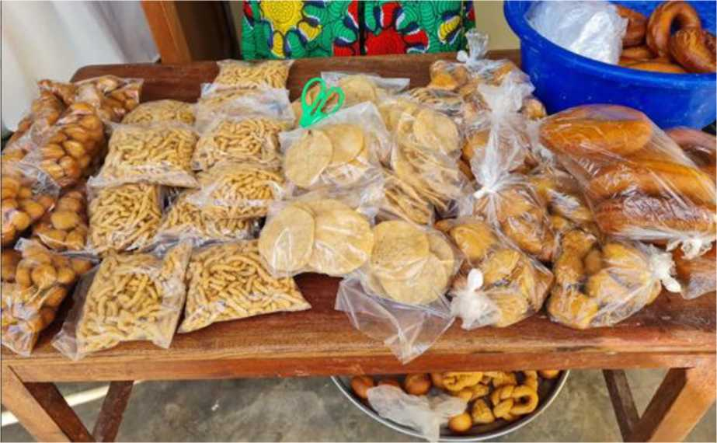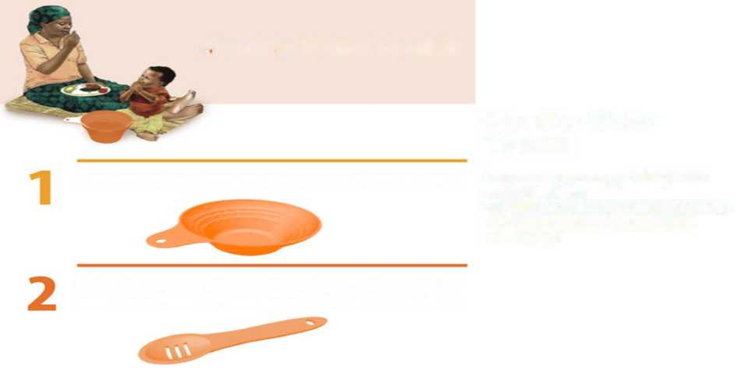

^AFSP

global agriculture & food security program

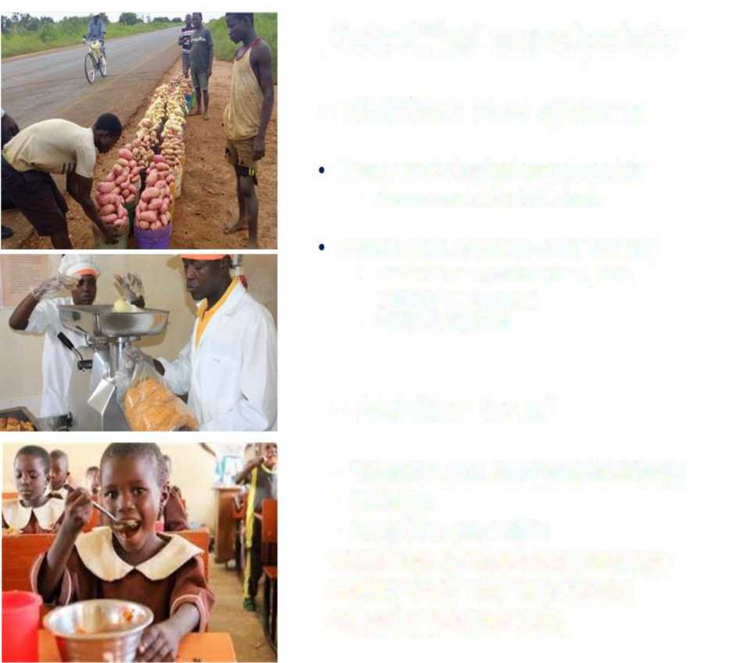

Biofortified sweetpotato

*= Nutritious food systems*

*= Nutrition for all*

Figure 3: Nutrition-sensitive pathways for OFSP utilization in improving nutrition and food security

Puree (cold chain to shelf stable)

• Versatile use (school meals, food industry innovations)

• >95% of nutrients

Fresh roots traded country-wide

• Among most affordable foods

• Vitamin A and other micronutrients

• Calories

• Easy fit in local diets

Guidelines for household utilization

Healthy Baby Tool Kit (6-23 mo) As part of healthier diets

Frozen OFSP puree

OFSP puree

Ready-made dough containing OFSP puree and chapati made with OFSP puree

Figure 4: OFSP puree baked and fried products

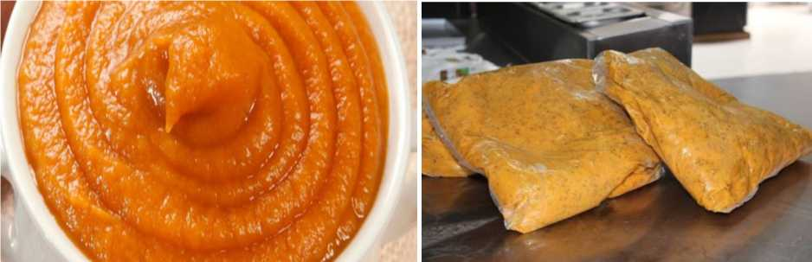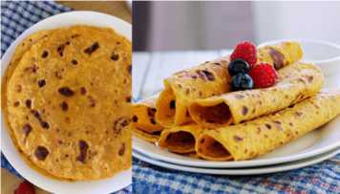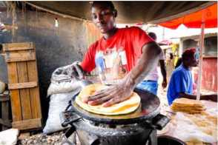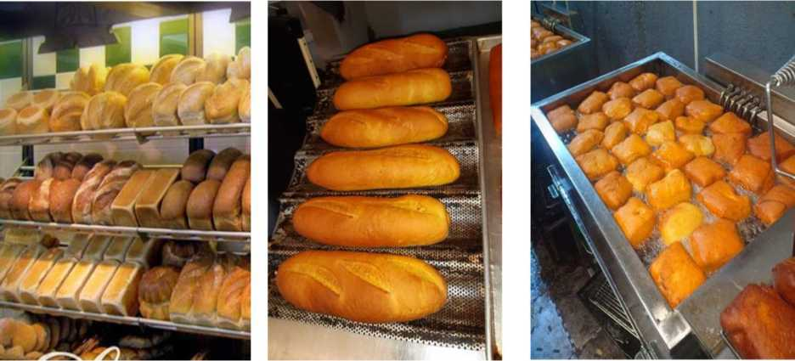

1. If any cross-cutting themes were selected in Section 3.1, this table must include some indicators that correspond to the selected theme(s) .
2. If this is unknown, write TBD (to be determined).
3. Please identify indicators that can clearly represent the causal links in the results chain that bridge the gap between the current status and the objectives (desired high-level indicator). Ideally, under each component there is at least one outcome indicator and correspondent output indicator(s).
4. This could include the potential effects on natural resources such as water sources, forests, and protected areas; potential effects on biodiversity; and where appropriate, potential impacts on the climate arising from unchecked anthropogenic emissions of greenhouse gases (GHGs) and short-lived climate pollution (SLCPs).
5. This could include the potential effects on human health and safety; the nature, scale, and duration of social effects such as the need for land acquisition and/or involuntary resettlement; potential impacts on, equity, and indigenous peoples; and potential impacts on physical cultural resources.